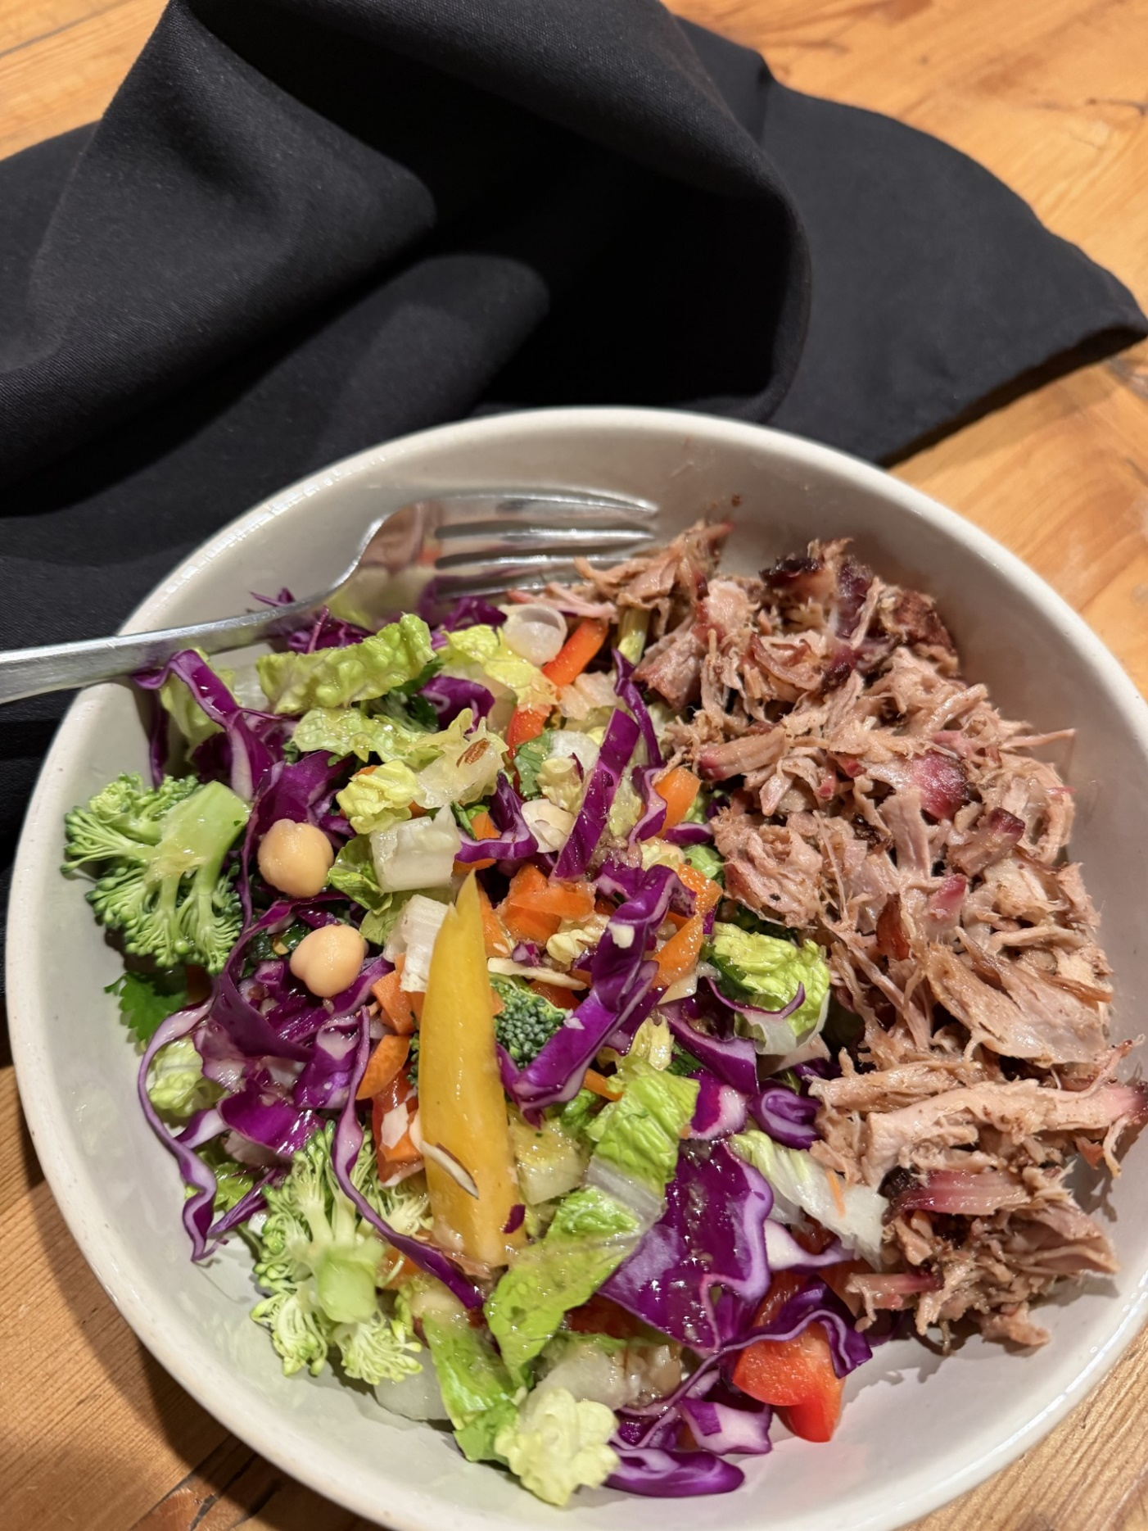
Preparation Time: 15 Cooking Time: N/A Serves: 4 Difficulty: Super Easy

mins Cooking Time: N/A Serves: 4 Difficulty: Easy
DIRECTIONS
- In a large serving bowl, combine all the prepared rainbow salad ingredients. Chop the lettuce with a ceramic knife to prevent the lettuce from browning.
- In a blender or bowl, combine all the dressing ingredients. I find whisking in a bowl works fine.
- Refrigerate, keeping the dressing separate until ready to serve.
INGREDIENTS
6 cups of Romaine lettuce, chopped
2 cups red cabbage, shredded
3 cups broccoli florets
1 red bell pepper/capsicum sliced & halved
2 green onions, sliced on the angle
4 tablespoons cilantro/coriander, chopped
1 can of chickpeas, drained & rinsed
2/3 cup carrots, peeled & chopped
1/3 cup toasted sliced almonds

Dressing
4 tablespoons olive oil
2 teaspoons sesame oil
1/3 cup apple cider vinegar
2 tablespoons freshly chopped or minced ginger
2 tablespoons lime juice, freshly squeezed
1.5 tablespoons genuine maple syrup
Salt to taste

Notes
I like to double the dressing when serving with some type of meat. I recommend serving with chicken or pulled pork., smoked optional.

Fresh lime juice and ginger is highly recommended and well worth the extra effort!

Rainbow Chopped Salad with Ginger Lime Dressing

