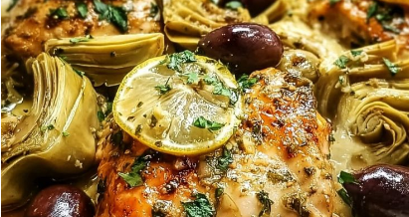
DIRECTIONS
- Pat dry chicken breasts and season with salt and pepper. I like to dry brine my chicken in advance for maximum juicy chicken that does not dry out. This just involves salting the chicken more heavily and placing in the fridge for several hours. It does not make the chicken salty if that is your concern. It just locks in the moisture.
- In a large pan, heat olive oil over medium to high heat. Add chicken and sear for 5-7 minutes each side until golden brown. I prefer medium heat to ensure it does not burn at high altitude. Then set aside to rest.
- In the same pan reduce heat to medium, add a little more olive oil and add onions. Sauté for 3 mins until translucent, then reduce heat to low and add garlic, cook for another minute until fragrant. Key is not to cook garlic at too high of heat as it becomes highly acidic (bitter).
- Pour in chicken broth, lemon juice, and lemon zest. Increase heat to medium-high, scrape and incorporate all the chicken brown bits.
- Return chicken to pan and add artichoke and olives. Coat chicken and let simmer on low heat for 5-10 mins. Internal temperature of chicken should reach 155f, let rest in sauce until it reaches 165f.

Preparation Time: 15 mins Cooking Time: 30 mins Serves 4 Difficulty: Easy
INGREDIENTS
4 chicken breasts
4 garlic cloves, minced
1 cup artichoke hearts (canned or jarred)
½ cup kalamata olives, pitted and sliced
½ cup diced onion
¼ cup lemon juice, freshly squeezed
1 tablespoon lemon juice
½ cup chicken broth
Olive oil
Salt & pepper to taste
Fresh parsley, finely chopped for garnish (optional)

Recipe Adds
- Add capers
- Heavily sprinkle freshly grated parmesan over top of the chicken.

Serving Accompaniment Suggestions
- Roasted baby potatoes or crispy smashed baby potatoes topped with avocado crema and whipped lemon ricotta
- Lightly grilled asparagus
- Greek lemon rice or orzo

Mediterranean Lemon Chicken with Artichokes & Olives

